**Task 1  
“=“** is used to as an identifier and can be changed later in the code

**“equ”** is used to store values as constants and cannot be changed further

**“textequ”** is used to store values as constants but can be changed later

**Task 3**

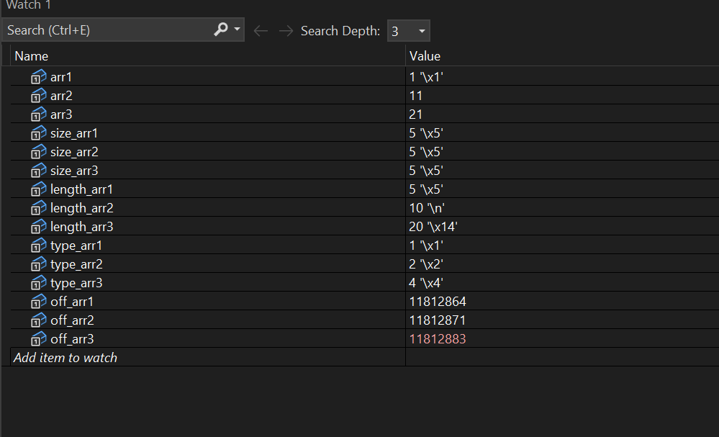

**Task 4**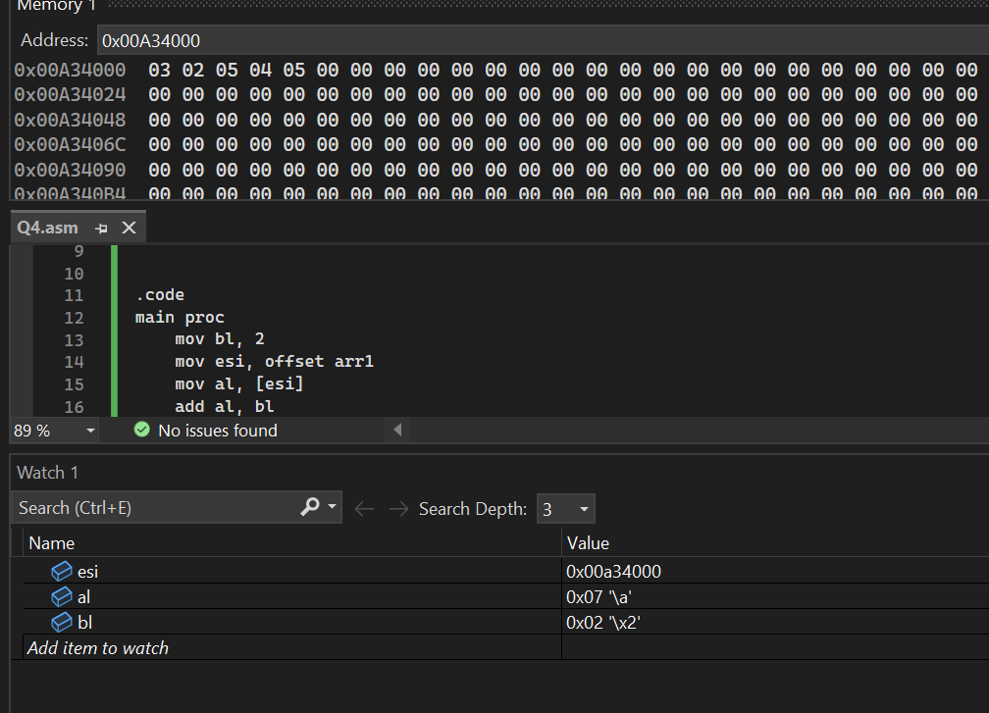

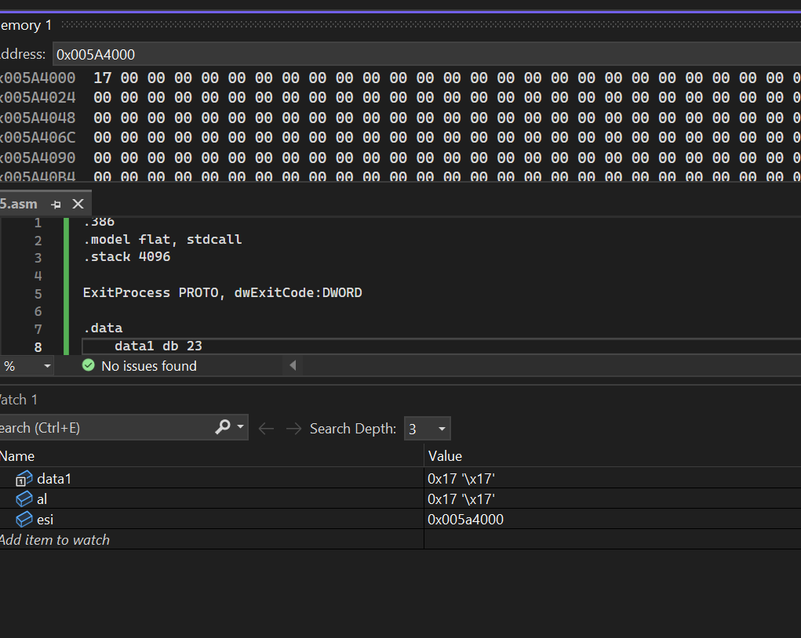**Task 5**

**Task 6**

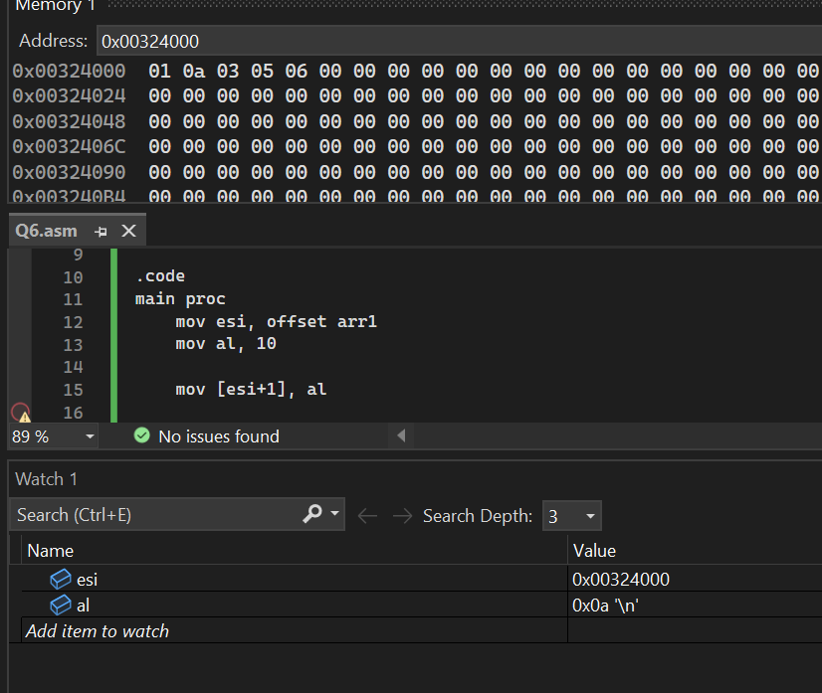

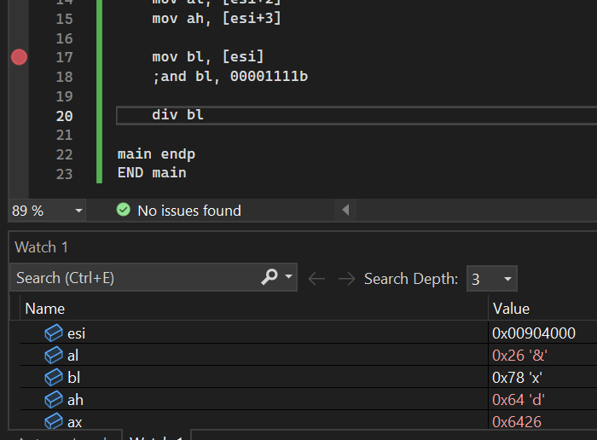**Task 7**

**Task 8**

